- Page 1- Design 1
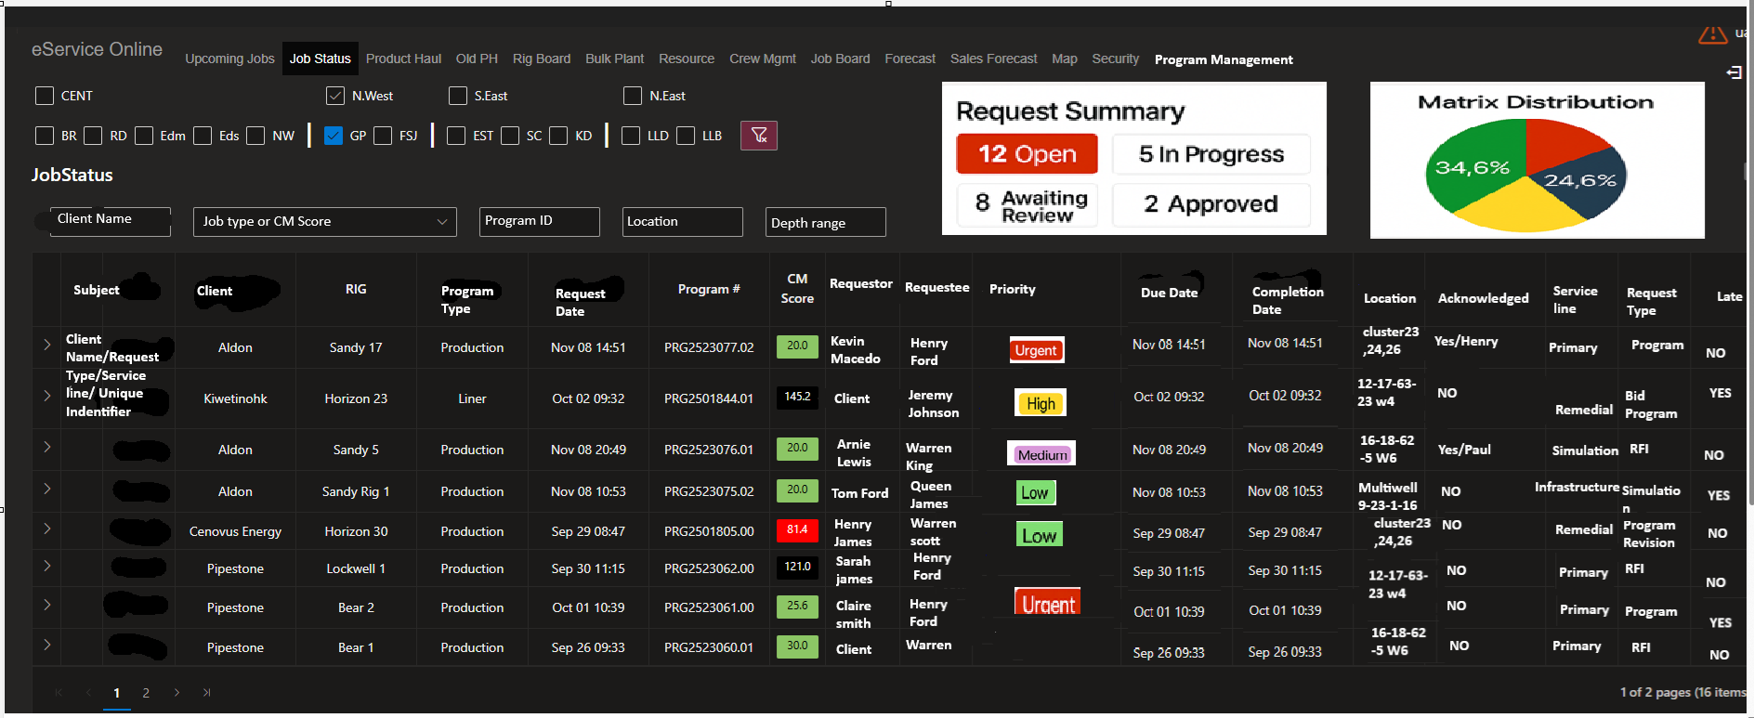
- Page 1- Design 2 by Jason
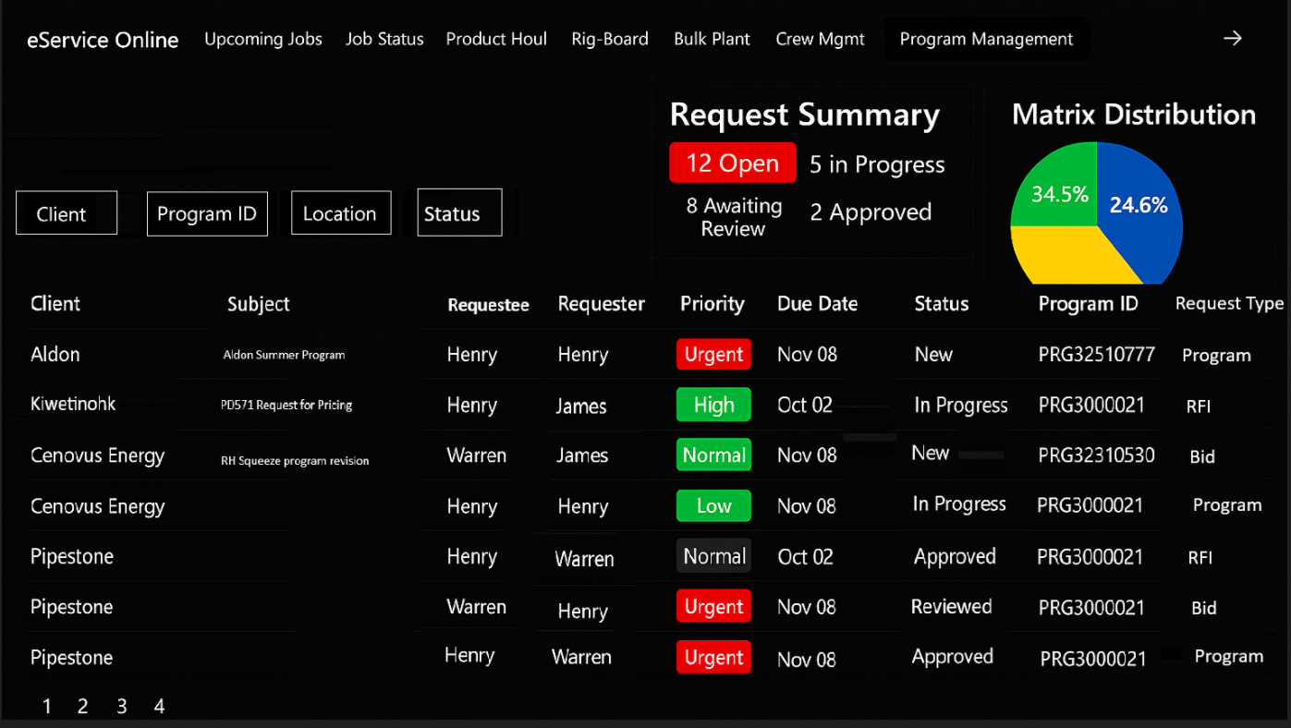

- Engineer Ticket view
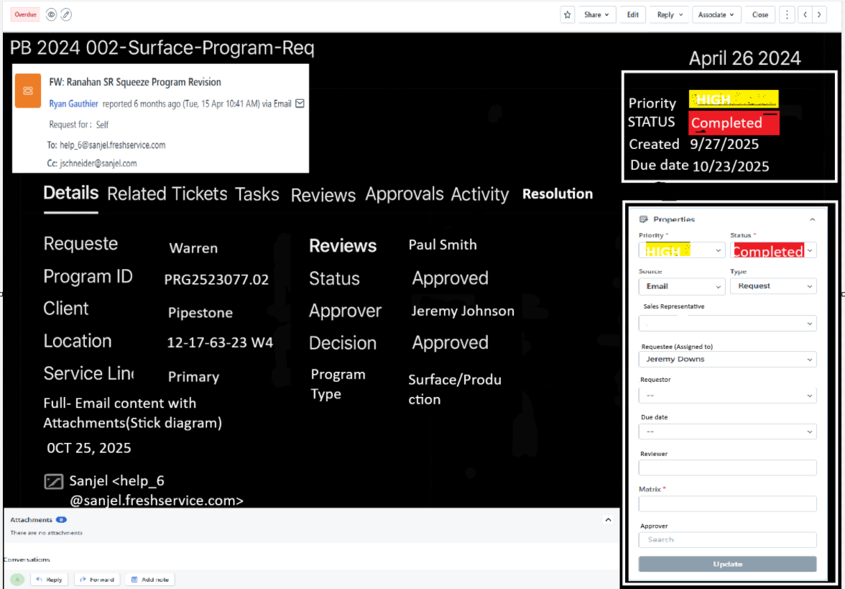
- When you click on Activity, it should be like this, just change background to black
- When you click on Resolution
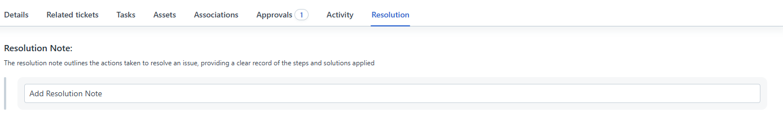
- When you click on Approval
